**KUBERNETES TASK 2**

1.Create a Simple Pod Using YAML

Task: Write a YAML file to create a Pod named firstpod with an nginx container. Verify the Pod creation using kubectl get pods and check the logs of the container using kubectl logs firstpod.

First we need to install yaml extension in terraform and we have edit the settings and goto extensions settings and edit the code in json

{  
    "yaml.schemas": {  
        "kubernetes": "*.yaml"  
    },    "yaml.customTags": [    ],  
    "[python]": {  
        "editor.formatOnType": true  
    }  
}

After that save and exit

Create a file first.yaml Now write the script this is for checking the errors

apiVersion: v1

kind: Pod

metadata:

    name: firstpod

    labels:

      env: prod

spec:

  containers:

    - name: test

      image: nginx

and goto masterk8 instance

vi first.yaml

apiVersion: v1

kind: Pod

metadata:

name: firstpod

labels:

env: prod

spec:

containers:

- name: test

image: nginx

now, To create pod using yaml file:

kubectl create -f <file_name>.yml --dry-run --> to check the output

kubectl create -f <file_name>.yml

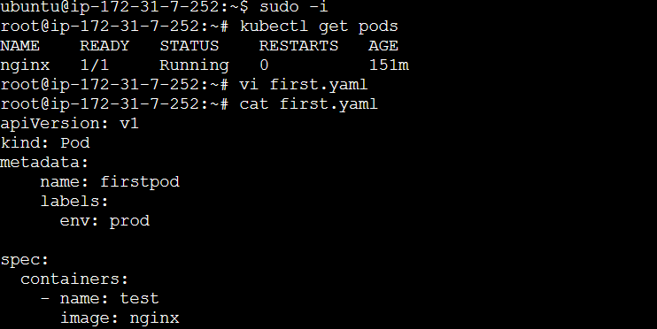

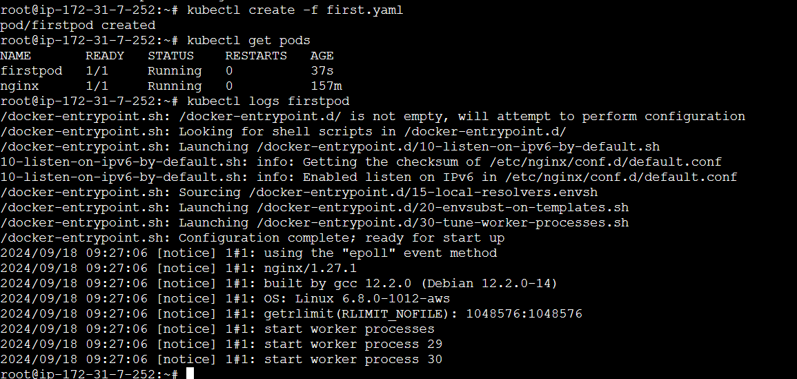

2)Set Environment Variables in a Pod

Task: Modify the YAML file to include environment variables myname: sabair and City: Hyderabad. Deploy the Pod and use kubectl exec <pod_name> -- env to check if the environment variables are set properly.

vi firt.yaml

Set Env Variables inside container Pods:

=======================================

apiVersion: v1

kind: Pod

metadata:

name: firstpod

labels:

env: prod

name: sabair

spec:

containers:

- name: nginx

image: nginx

env:

- name: myname

value: sabair

- name: City

value: Hyderabad

How to check the variables using kubectl?

**kubectl exec <Pod_name> -- env --> If one container is runnind inside pod**

kubectl exec <pod_name> -c <container_name> -- env --> To run command in specific container

kubectl exec <pod_name> -it bash --> To login inside the pod if one container is running

kubectl exec <pod_name> -c <container_name> -it bash --> Login to specific container

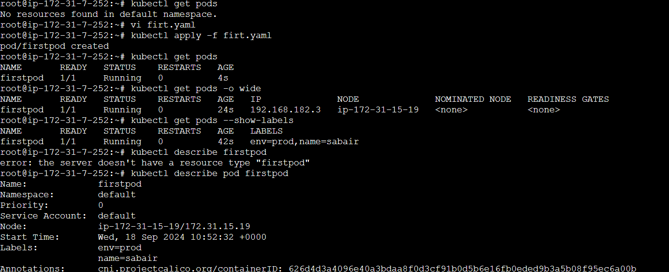

**kubectl exec <Pod_name> -- env --> If one container is runnind inside pod**

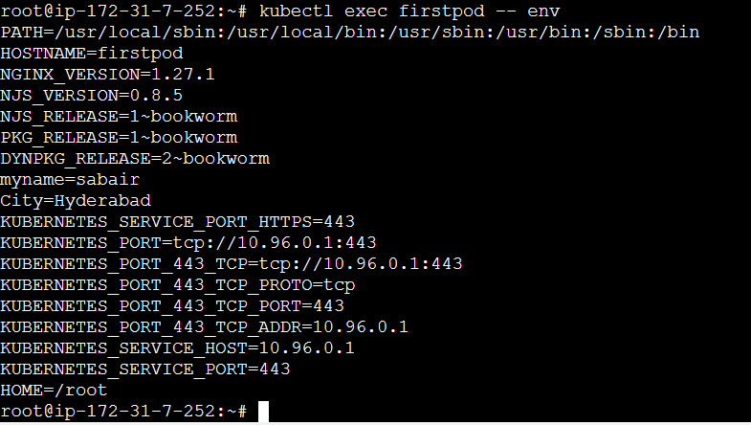

To login into the pod

login to the node where the container is running and execute the below command

docker exec -it <container_id> env

4) Deploy a Pod with Commands (Args) in YAML

Task: Modify the YAML file to add args that instruct the container to sleep for 50 seconds. Deploy the Pod and use kubectl describe pod to verify the args are correctly passed to the container.

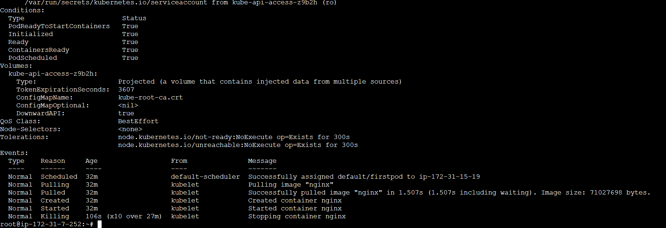

5) Set Up an Init Container in a Pod

Task: Modify the YAML to include an init container that sleeps for 30 seconds before the main containers start. Verify the init container's execution using kubectl describe pod and check the logs to confirm its completion.

apiVersion: v1

kind: Pod

metadata:

  name: firstpod

  labels:

    env: prod

    name: sabair

spec:

  containers:

  - name: firstcontainer

    image: nginx

    env:

      - name: myname

        value: sabair

      - name: City

        value: Hyderabad

  - name: secondcontainer

    image: nginx

  initContainers:

  - name: initcontainer

    image: nginx

    env:

      - name: myname

        value: sabair

      - name: City

        value: Hyderabad

    args: ["sleep", "30"]

kubectl apply -f firt.yaml

kubectl get pods

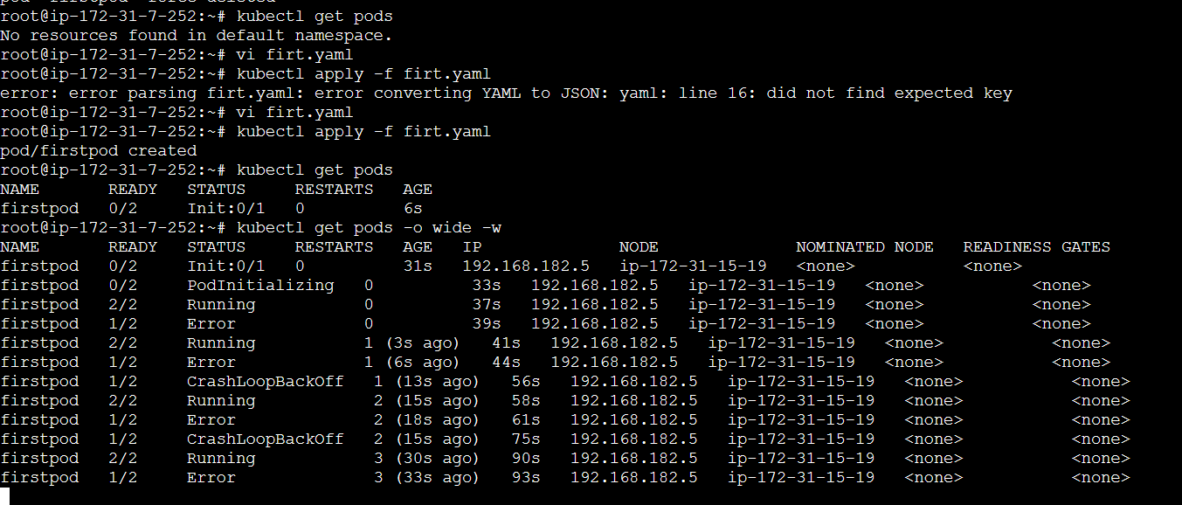

6) Run a Dry Run Command to Generate YAML

Task: Use the kubectl run nginx --image=nginx --dry-run=client -o yaml command to generate a Pod YAML definition. Modify the generated YAML to suit specific requirements (e.g., labels or environment variables) and deploy it.

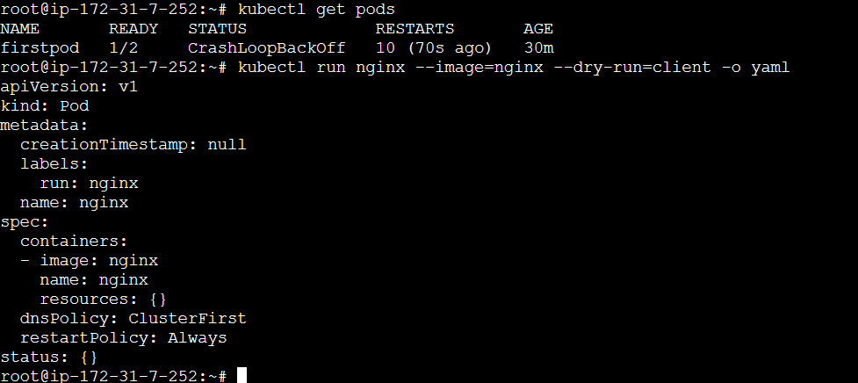

Kubectl describe pod firstpod

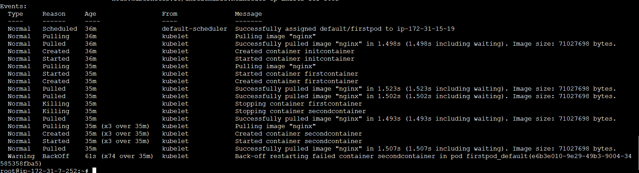

7) Use kubectl apply vs kubectl create

Task: Create a YAML file to define a Pod. First, deploy it using kubectl create -f <file_name>.yml and then modify the YAML (e.g., change the image version). Use kubectl apply to redeploy and verify the difference between both command

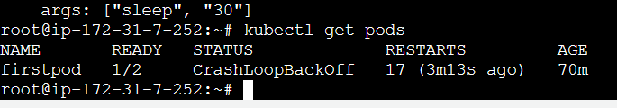

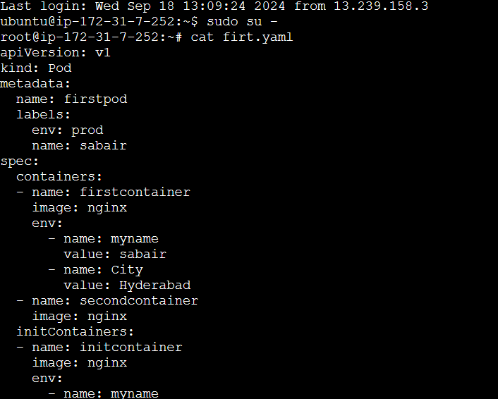



8) Edit an Existing Pod Configuration

Task: Use kubectl edit pod <pod_name> to modify the running Pod's environment variables or image. After making the changes, verify if they took effect by checking the container logs or environment variables using kubectl exec.

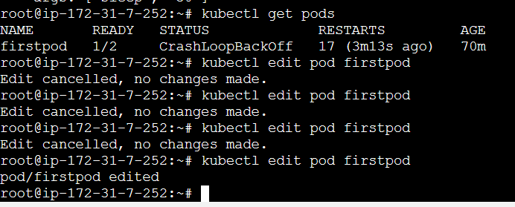

9) Expose a Pod Using a Service

Task: Create a YAML file to expose your firstpod using a Service (ClusterIP). Ensure that your service is exposing the Pod on port 80 and verify it using kubectl get svc.

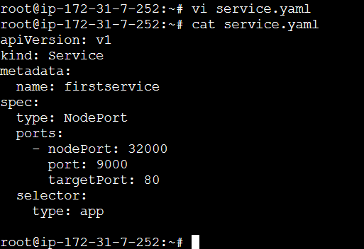

Ensure that your service is exposing the pod on port 80 and verify it using

Kubectl get svc

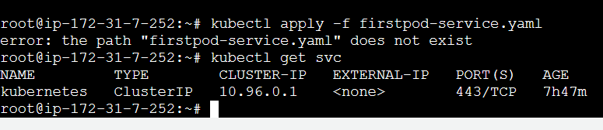

10) Pod with Resource Limits and Requests

Task: Add resource requests and limits to the containers in your YAML file. Specify CPU and memory requests/limits for both containers and deploy the Pod. Use kubectl describe pod to verify if the resource configurations are correctly applied.

